Name of Student: Akshit Kumar | PRN:25070122270
Semester: III | Year : AY 2026-27
Subject: Programming with Java
ASSIGNMENT No : 8
TITLE : Super Keyword in Java
Problem Statement
Write a Java program to demonstrate the use of the super keyword in inheritance.
Learning Objectives
To demonstrate the use of the super keyword for accessing parent class members.

Programme
1.Create an Employee and Manager program where Manager accesses Employee details using super keyword.
class Employee {
String name;
int salary;
Employee(String name, int salary) {
this.name = name;
this.salary = salary;
}
void displayEmployee() {
System.out.println("Employee Name: " + name);
System.out.println("Employee Salary: " + salary);
}
}

class Manager extends Employee {
String department;
Manager(String name, int salary, String department) {
super(name, salary);
this.department = department;
}
void displayManager() {
super.displayEmployee();
System.out.println("Department: " + department);
}
}
public class emp {
public static void main(String[] args) {
Manager m = new Manager("Akshit", 50000, "IT");
m.displayManager();
}
}

2. Develop a Vehicle Insurance System where child insurance classes access parent vehicle information using the super keyword.
class Vehicle {
String vehicleNumber;
String vehicleType;
Vehicle(String vehicleNumber, String vehicleType) {
this.vehicleNumber = vehicleNumber;
this.vehicleType = vehicleType;
}

void displayVehicle() {
System.out.println("Vehicle Number: " + vehicleNumber);
System.out.println("Vehicle Type: " + vehicleType);
}
}
class CarInsurance extends Vehicle {
double premium;
CarInsurance(String vehicleNumber, String vehicleType, double premium) {
super(vehicleNumber, vehicleType);
this.premium = premium;
}
void displayInsurance() {
super.displayVehicle();
System.out.println("Insurance Premium: " + premium);
}
}
class BikeInsurance extends Vehicle {
double premium;
BikeInsurance(String vehicleNumber, String vehicleType, double premium) {
super(vehicleNumber, vehicleType);
this.premium = premium;
}

void displayInsurance() {
super.displayVehicle();
System.out.println("Insurance Premium: " + premium);
}
}

public class VehicleInsurance {
public static void main(String[] args) {
CarInsurance car = new CarInsurance("MH12AB1234", "Car", 15000);
BikeInsurance bike = new BikeInsurance("MH14XY5678", "Bike", 8000);
System.out.println("Car Insurance Details:");
car.displayInsurance();
System.out.println();
System.out.println("Bike Insurance Details:");
bike.displayInsurance();
}
}

Output
1)

2)
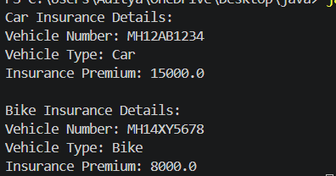

Conclusion
Both programs successfully demonstrate the concepts of inheritance and the super keyword in Java.

